String (OR) str datatype

In python string is collection type.
String is sequence datatype. It organize string data in sequential order.
String is non numeric data type, we cannot perform arithmetic operations on string.
String is collection of characters. These characters can be alphabets, digits or special characters.
The string which contains only alphabets is alphabetic string
This string which contains alphabets and digits is called alphanumeric string.

How to represent string in python?
In python string is created or represented,
- Within single quotes
- Within double quotes
- Within triple single quotes or double quotes

Within single quotes
Within single quotes we represent single line string.
In this, the string must begin and end with single quotes
Within single quotes double quotes can be embedded (inserted)

>>> course='python'
>>> type(course)
<class 'str'>
>>> course
'python'
>>> name='naresh'
>>> type(name)
<class 'str'>
>>> name
'naresh'
>>> s1='python"
SyntaxError: unterminated string literal (detected at line 1)
>>> s2='python
SyntaxError: unterminated string literal (detected at line 1)
>>> s2='15'
>>> type(s2)
<class 'str'>
>>> s2
'15'
>>> s3='A101'
>>> s3
'A101'
>>> type(s3)
<class 'str'>
>>> password='abc123@%$'
>>> type(password)
<class 'str'>
>>> password
'abc123@%$'
>>> s1='python is "easy" programming language'
>>> s1
'python is "easy" programming language'
>>> s2='python is 'easy' programming language'
SyntaxError: invalid syntax. Is this intended to be part of the string?
>>> s3='python''lanaguage'
>>> s3
'pythonlanaguage'

Within double quotes
Within double quotes we can represent single line string
In this, the string begins and ends with double quotes
Within double quotes we can insert single quotes

>>> str1="python"
>>> str1
'python'
>>> type(str1)
<class 'str'>
>>> str2="65"
>>> str2
'65'
>>> type(str2)
<class 'str'>
>>> str3="A65"
>>> str3
'A65'
>>> type(str3)
<class 'str'>
>>> str4="Python programming language"
>>> str4
'Python programming language'
>>> str5="Python "easy" programmin language"
SyntaxError: invalid syntax. Is this intended to be part of the string?
>>> str5="Python""Programming Language"
>>> str5
'PythonProgramming Language'
>>> str6="Python 'easy' programming langauge"
>>> str6
"Python 'easy' programming langauge"
>>> type(str6)
<class 'str'>

Triple quotes
Triple quotes are used for representing multiline string
These triple quotes can be,
- Triple single quotes
- Triple double quotes
The string open with triple single quotes must close with triple single quotes only
The string open with triple double quotes must close with triple double quotes only

>>> str1='''python
programming
language'''
>>> print(str1)
python
programming
language
>>> str1
'python\nprogramming\nlanguage'
address='''Naresh i Technologies,
Ameerpet,
Hyd-30'''
>>> print(address)
Naresh i Technologies,
Ameerpet,
Hyd-30
>>> str3="""python
programming
language"""
>>> print(str3)
python
programming
language
address="""Naresh i technologies,
Ameerpet,
Hyd"""
>>> print(address)
Naresh i technologies,
Ameerpet,
Hyd
>>> s1='''python
... programming
... langauge"""
... '
... '''
>>> print(s1)
python
programming
langauge"""
'

Escape Sequences or Backslash character values
These are special sequences or character having special meaning within string. These are represented within string.

Escape Sequence | Meaning
\n | New line
\t | Horizontal tab space
\v | Vertical tab space
\b | Backspace
\\ | \
\’ | ‘
\” | “

>>> s1='python \' programming langauge'
>>> print(s1)
python ' programming langauge
>>> s2='python \'programming\' language'
>>> print(s2)
python 'programming' language
>>> s3="python \" programming language"
>>> print(s3)
python " programming language
>>> s4="python \"programming\" language"
>>> print(s4)
python "programming" language
>>> s5='python\njava\noracle\nHTML'
>>> print(s5)
python
java
oracle
HTML
>>> s1="Monty Python's Flying Circus"
>>> print(s1)
Monty Python's Flying Circus
>>> s2='Monty Python\'s Flying Circus'
print(s2)
Monty Python's Flying Circus
>>> s3="\"
SyntaxError: unterminated string literal (detected at line 1); perhaps you escaped the end quote?
>>> s3="\\"
>>> print(s3)
\
url=c:\\nit"
SyntaxError: invalid syntax
>>> path="c:\\nit"
>>> print(path)
c:\nit
>>> path="c:\nit"
>>> print(path)
c:
it
>>> path="c:\\nit"
>>> print(path)
c:\nit
>>> s1="\trollno"
>>> print(s1)
rollno
>>> s2="rollno\tname\tcourse"
>>> print(s2)
rollno name course

Note: python does not support single character data type. In python single character also represented as string.

Comments in python
In python any statement begin with # is comment
Comments are ignored or not executed by python runtime system.
Comments are used to describe the statements or instructions.
Python support single line comment (#)

#comment
Statement #comment
Example:
'''Title: Calculator
Version :1.0
Author: Satish Gupta
Date Written : 10-11-2025
Date Last Updated : 10-11-2025'''

#rollno of student
rno=105
#student name
sname="naresh"
#course name
cname="java"
fee=5000 #fee
print(rno,sname,cname,fee)

Output
105 naresh java 5000

How to see documentation?
>>> import test6
105 naresh java 5000
>>> test6.__doc__
'Title: Calculator\nVersion :1.0\nAuthor: Satish Gupta\nDate Written : 10-11-2025\nDate Last Updated : 10-11-2025'
>>> print(test6.__doc__)
Title: Calculator
Version :1.0
Author: Satish Gupta
Date Written : 10-11-2025

What is indent in python?
Space given at beginning of the statement is called indentation.

In python statements should not begin with space
In python space is used for creating block
It is used to include statements within block.
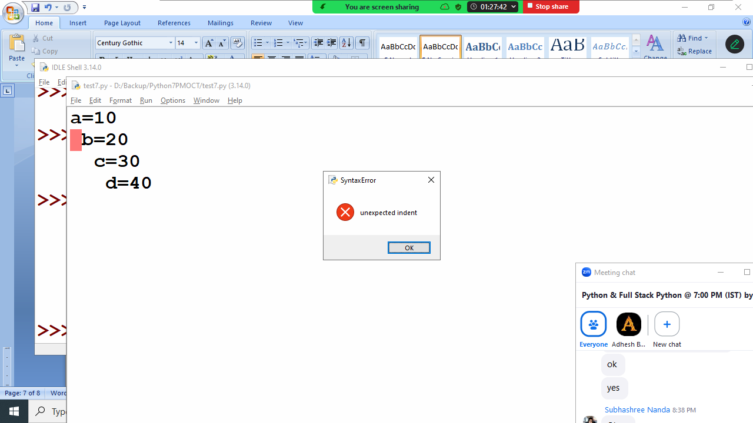

Every program required 3 things
- Input
- Process
- Output

